ECMS PROJECT

FINAL YEAR PROJECT

DATE

University College of technology

CANDIDATE NUMBER

**Abstract**

First of all, we thank God SWC for making it possible for us to start and finish our university safely. I would like to thank our teachers who have spent a lot of time and effort to reach this stage today. We are also very grateful to all our parents for their great honour and value who made it possible for us to finish our first level education today and who gave us all the funds that were spent on our education.

We also thank the students who have been our classmates for the past four years and we have been in the long struggle of education, while we have spent beautiful times and good times together.

Also, thanks to everyone who contributed to the production of our book in defense of our project named ECMS and will graduate.

We also thank everyone who took the time to read our book and thank you very much for the beautiful time you gave us on your day.

**Table Contents**

**Problem Definition & Human Information Requirements** 6

**Analyzing System Needs** 10

**Users** 13

**House** 13

**Renter** 14

**Environment** 14

**Services** 15

**Transaction** 15

**Developing & Documenting System** 16

**Login Section** 16

**Dashboard Section** 19

**User Accounts** 23

**House Section** 29

**Renter Section** 31

**Environment Section** 33

**Services Section** 35

**Transaction Section** 38

**Conclusion** 41

# **Problem Definition & Human Information Requirements**

**Introduction**

Before we go into the details and summary of our book, we would like to report and briefly talk about the things that our project is doing? And why did we choose to do this project?

First of all, our group consists of 7 people, all of us who want to graduate from Himilo University this year, we are among the students of the college of computer science, especially we are going to graduate from programming.

Our group has agreed that we have chosen a system to solve and manage the issue of the environmental cleaning system so that the system is supposed to work properly.

The system is called Environmental Cleaning System (ECS) and will solve all the needs of environmental cleaning by solving it in a technological way.

The system can register all the houses in the Banadir region and each district will be registered in each house and at the same time the houses that belong to the citizens will be registered.

It will also be registered for each tenant and each tenant will be filled in with their information and at the same time the tenant and the house they are renting will be found.

In addition to this, the system will find out how many areas have been cleaned and how many areas have not yet been cleaned.

Also, the system has good security authentication and no one can log in except those who are in the system.

Also, we will explain here how we did it and the language we used to make the system.

There are many programming languages such as HTML, JAVA, JAVASCRIPT, C++ and so on. But this system or this project is named Environmental Cleaning Management System it is built in Python language.

The reason we use it is that it is the latest and easiest language not only does, we have used other programming languages such as HTML and Python. When you look at the system in its style and beauty, we built it in html as frontend. Html is a programming language that you can use to design or build your own front-end. While python is the easiest programming language in the world when we talk about programing language and we will use as backend.

There are more than 15 million people living in Somalia and they live in all the regions of our country.

The Somali community that lives in all the regions of our country, every community that lives in its region has services for social issues that are part of Health, Education, Sports and so on.

Cleanliness is a part of the faith, as reported by our Prophet CSW, it is essential that every area is clean so that people can have health.

In the last few years, our Somali country has been growing. In the last years, the country was emerging from the state of collapse. We have started to rebuild and repair some parts of our country, and most of the regions have been built.

Every region has modern houses and the population has been increasing day by day, and at the same time, the social services that every region has are increasing.

The environment needs to be clean for the community to be healthy, so in order to solve this need, a company that works in cleaning is needed and at the same time, it is considered as a sanitary service that will do the cleaning service in every area in every region.

Also, there are houses in every area, there are people living in every house, and every government agency is responsible for working in social services and at the same time, every area has its right.

Therefore, there is a need to create a modern system to manage the service, which is called the area cleaning project, that system will solve all the work needs in the area cleaning.

# **Analyzing System Needs**

The system has a database designed to store all the data, as well as something that will help the company to use the data whenever it is needed.

We named the database as System and named it "ecms_db" and it has the following lex tables:-

1. Users

2. Houses

3. Renters

4. Environments

5. Services

6. Transactions

We also set up and installed how they would work and we managed to improve the relationship between the tables of our database.

In the following sections, we will explain how the table of the database is built and the connections between our database.

|  |
| --- |
| **House** |
| Id |
| Name |
| district |
| Type |
| House_No |
| Status |

|  |
| --- |
| **Renter** |
| Id |
| Name |
| Tell |
| Martia_status |
| Status |

|  |
| --- |
| **User** |
| Id |
| Name |
| Gender |
| Tell |
| Username |
| Password |
| Active |
| Status |

|  |
| --- |
| **Enviroment** |
| Id |
| House_id |
| Renter_id |
| Register_date |
| Status |

|  |
| --- |
| **Services** |
| Id |
| date |
| Env_id |
| Status |

|  |
| --- |
| **Transactions** |
| Id |
| Account |
| Price |
| Date |
| Service_id |
| Status |

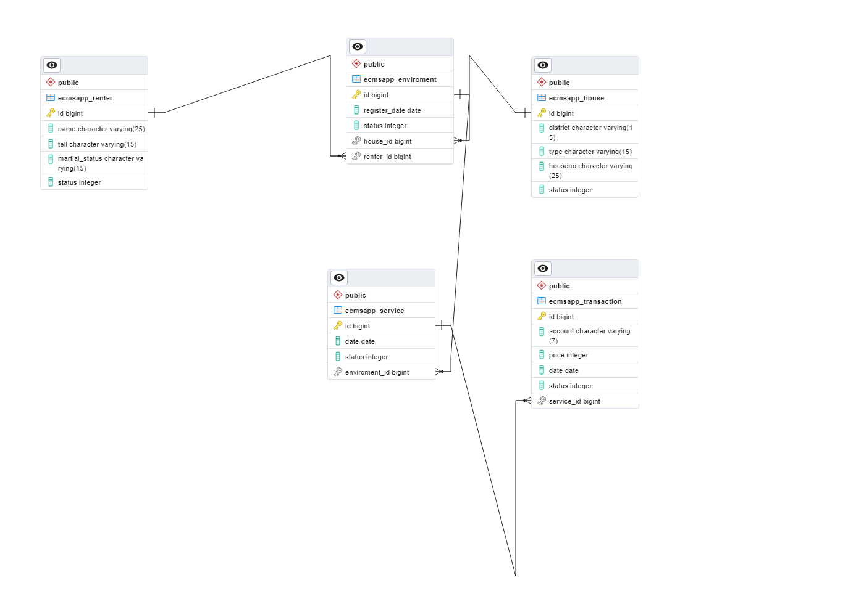ER-Diagram

## **Users**

It is intended to store all user data of the system user and will store all user data such as: name, telephone, email, nationality,gender, username and password.

|  |  |  |
| --- | --- | --- |
| No | Datatype | Value |
|  | ID | 1 |
|  | NAME | Hassan Sheikh Mohamud |
|  | Gender | Male |
|  | Tell | 061-0-000123 |
|  | Username | Admin |
|  | Password | Pass123 |
|  | Active | On |
|  | Status | True |

## **House**

It will be stored all the information of the owner of the house such as:- District, House No, House Type. Also, the data will be officially filed in the database

|  |  |  |
| --- | --- | --- |
| No | Datatype | Value |
|  | ID | 1 |
|  | District | Hodan |
|  | TYPE | Apartment |
|  | HOUSE NO | HDN-001 |
|  | Status | True |

## **Renter**

The renter is the tenant of the house and it is intended that all the information of the tenant will be filed here, such as name, telephone and marital status.

|  |  |  |
| --- | --- | --- |
| No | Datatype | Value |
|  | ID | 1 |
|  | NAME | Hassan Sheikh Mohamud |
|  | TELL | 061-0-000123 |
|  | Martial-status | MALE |
|  | Status | True |

## **Environment**

The environment has houses and people live in the house, so here will be registered our house and the tenant and the day he moved in such as: Renter_id, House_id and Register_Date

|  |  |  |
| --- | --- | --- |
| No | Datatype | Value |
|  | ID | 1 |
|  | House_id | 1 |
|  | renter_id | 1 |
|  | date | 05/11/2023 |
|  | Status | True |

## **Services**

It will be record here with all the information that the services will have such as the location where the service was performed, the date the service was performed.

|  |  |  |
| --- | --- | --- |
| No | Datatype | Value |
|  | ID | 1 |
|  | Enviroment_id | 1 |
|  | date | 05/11/2023 |
|  | Status | True |

## **Transaction**

This is where all the money collected from the customer will be filed. Every month, different information about the money will be filed.

|  |  |  |
| --- | --- | --- |
| No | Datatype | Value |
|  | ID | 1 |
|  | Account | EVC PLUS |
|  | Price | $5.00 |
|  | Date | 12/10/2023 |
|  | Service_id | 1 |
|  | Status | True |

# **Developing & Documenting System**

In this section, we intend to explain how the system is made and how to use our system. For each part of the system, we have made documentation related to how each part works and how to use it.

In the sections below, I will explain in detail how to use each section and what it does.

## **Login Section**

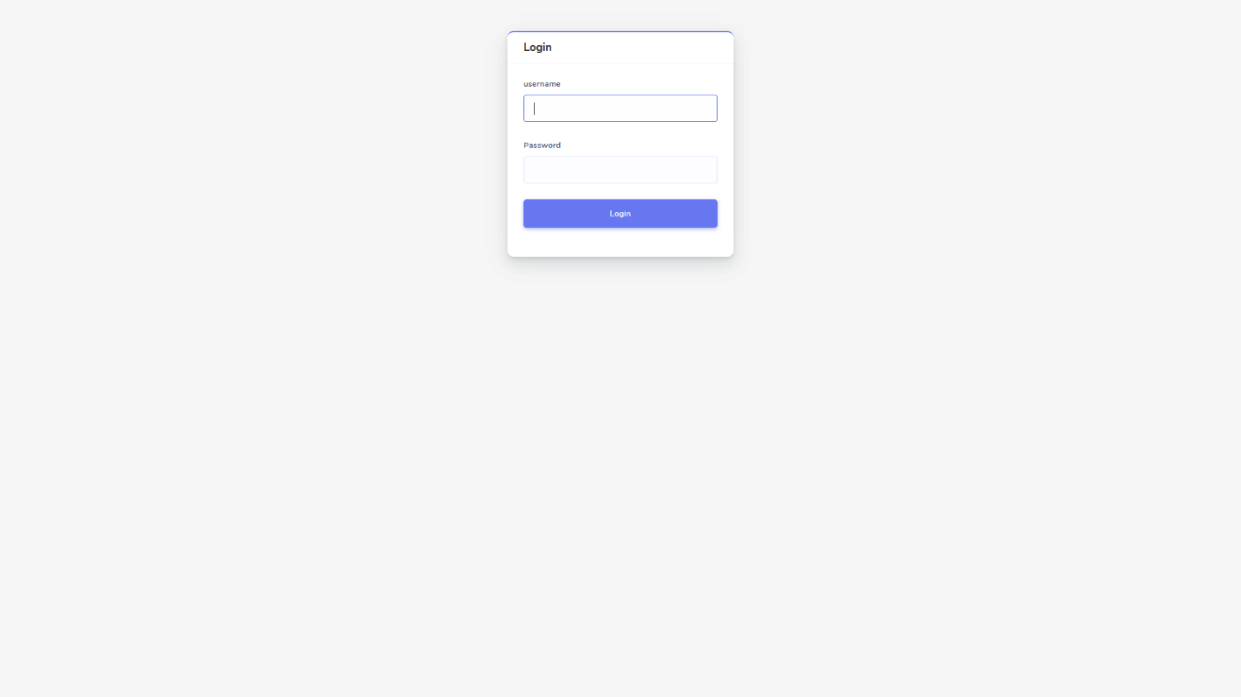We have created a check point for the system to ensure that the user is authorized to use the system, and we have named this process as the login process.

Figure 1 this figure shows you how login page is look like

The user will enter the username and password to access the system account to use the ECMS system, if the user enters the wrong username or password, the system will not allow that person to enter unless the person is banned by the check point. we have already set

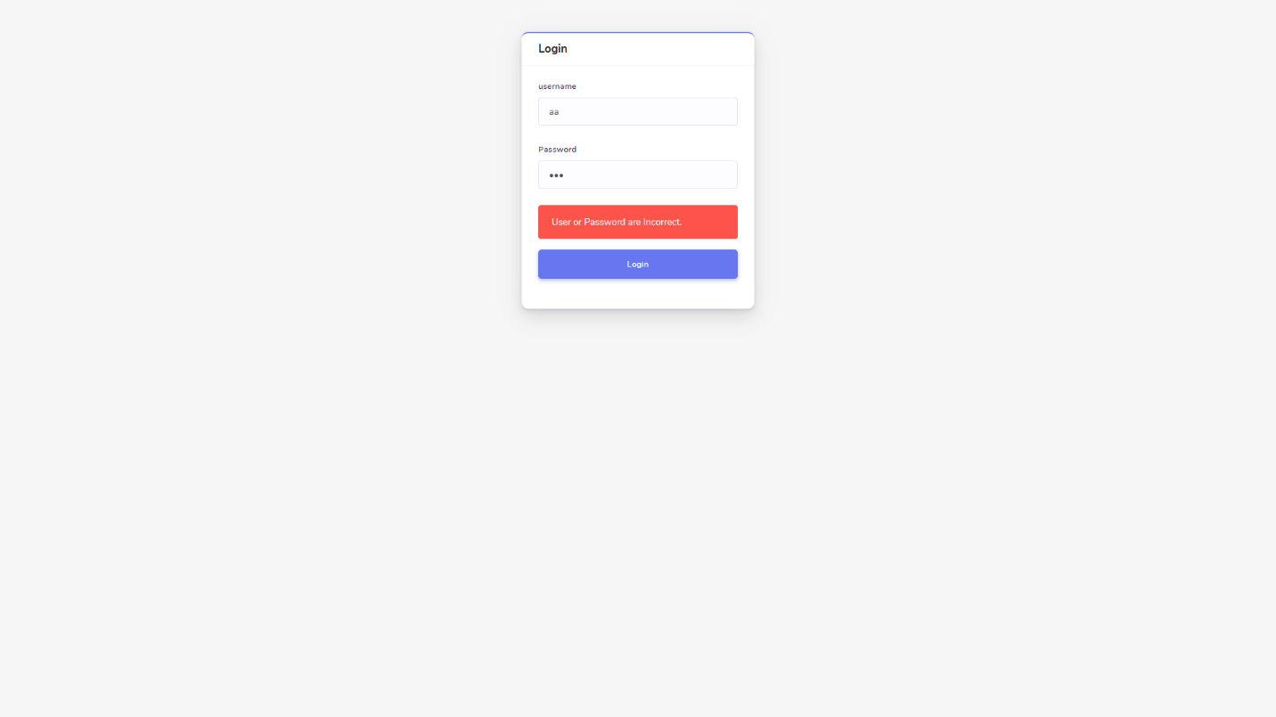

Figure 2 Incorrect Username or Password

Also, if the user enters a correct username and password, he will be allowed to use the system, and he will be taken to the part shown in the image, which is the Dashboard.

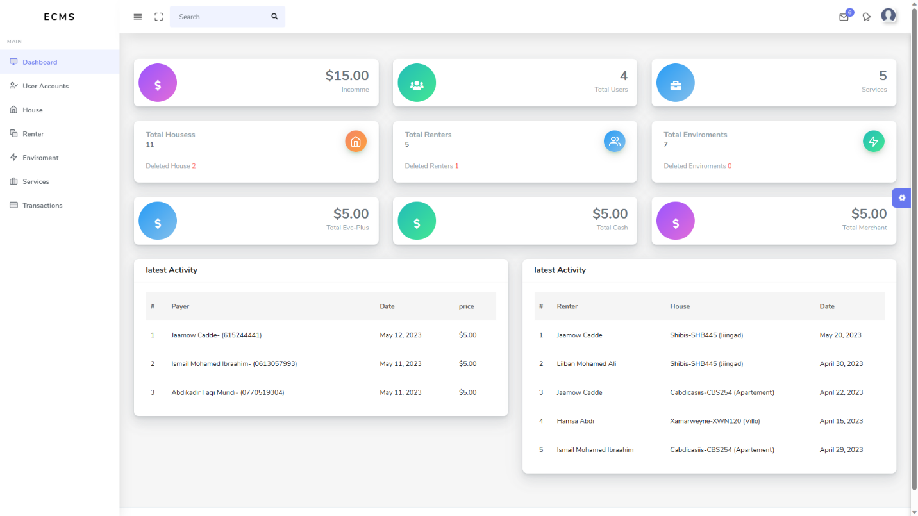

Figure 3 Dashboard View

## **Dashboard Section**

The dashboard section contains a lot of information, so this information comes from within the system, and this information includes all the total payments made by the company and the details of the accounts in which the payments were made and their total amount. It also shows the number of users. Lee's company, the dashboard also shows how many houses the company has registered, and the total number of tenants registered by the company.

The dashboard also shows how many sites have registered with our company and the total number of sites that have been serviced and collected.



Figure 4 Information Collected Within the system as a report

Also, there are two tables on the dashboard that contain information collected from the system. These two tables indicate the last 5 activities that the system has done. These two activities are found in the table of Transactions and Environments.

Also, the Dashboard system has a profile that is intended to display the user's information in the system and all the related information that the user in the 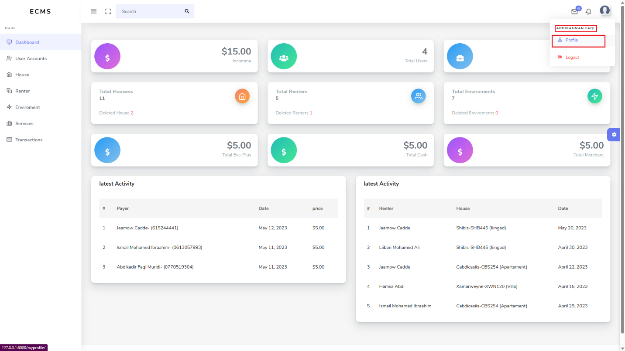system has.

Figure 5 Latest Top 5 Activity

Figure 6 displays the name of the user logged in system

It now shows the name of the user in the system, profile and logout, if the user clicks on the profile, he will be taken to the profile page and all the information related to the user will be displayed.

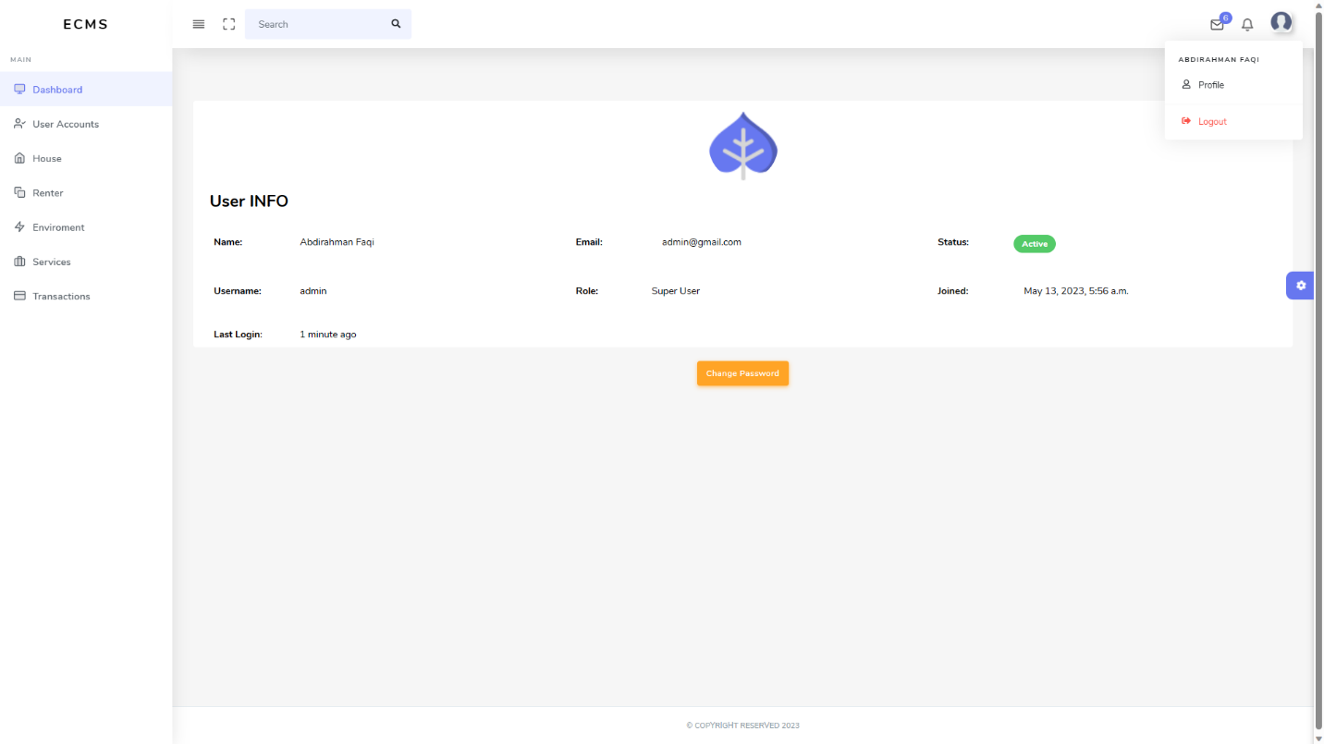As seen in the image below, it now shows how the profile page is looks like

Figure 7 Displaying Profile Page

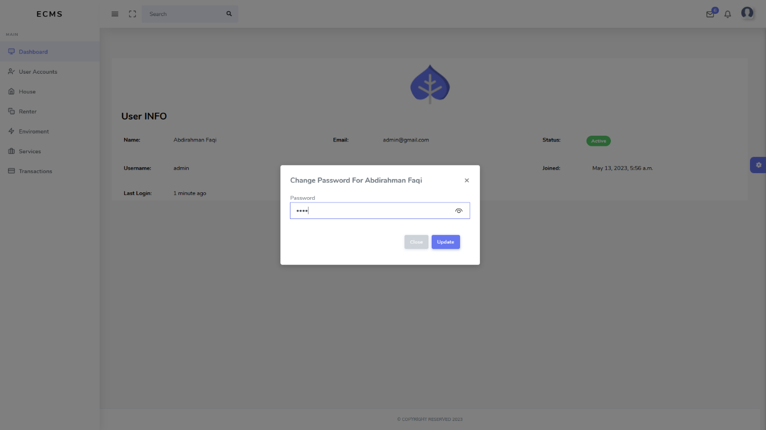If the user wants to change his password, he will click on the section that says Change Password, then Modal will pop up and he will enter the new password that he wants to use in the system.

Figure 8 Changing Password

After the user enters his new password and clicks on the Update button, a dialog box will appear detailing whether he has used it incorrectly or not.

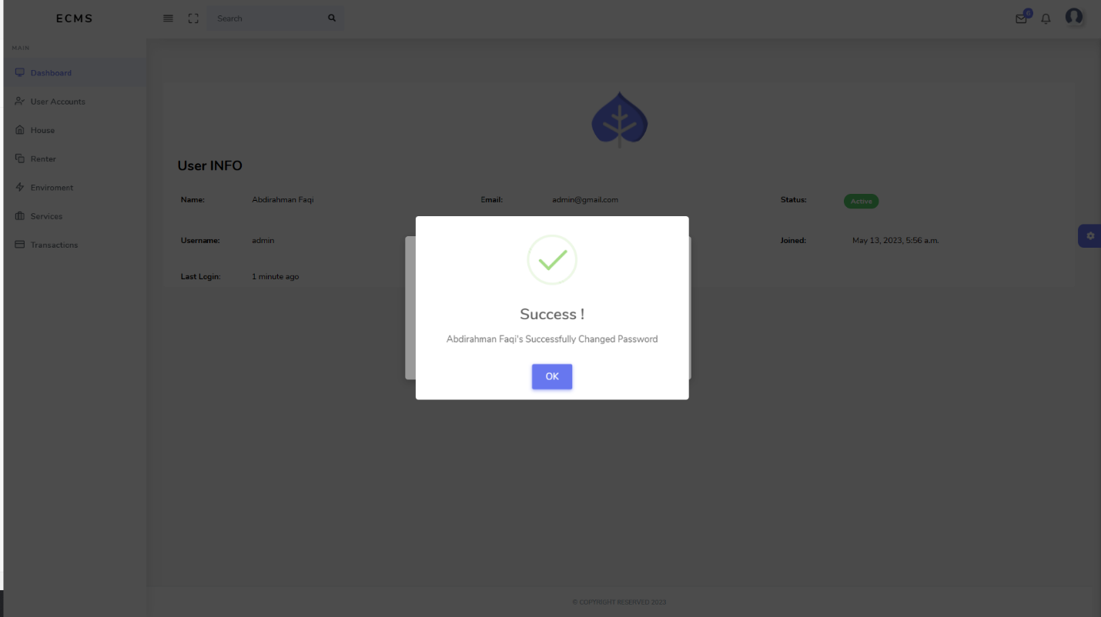If the user has used it correctly, a dialog box will be displayed that says you are successful in changing your password.

Figure 9 Success Message Displays

## **User Accounts**

The system user has the ability to create a user account and has the ability to see all the accounts in the system and those that are active and those that are not active.

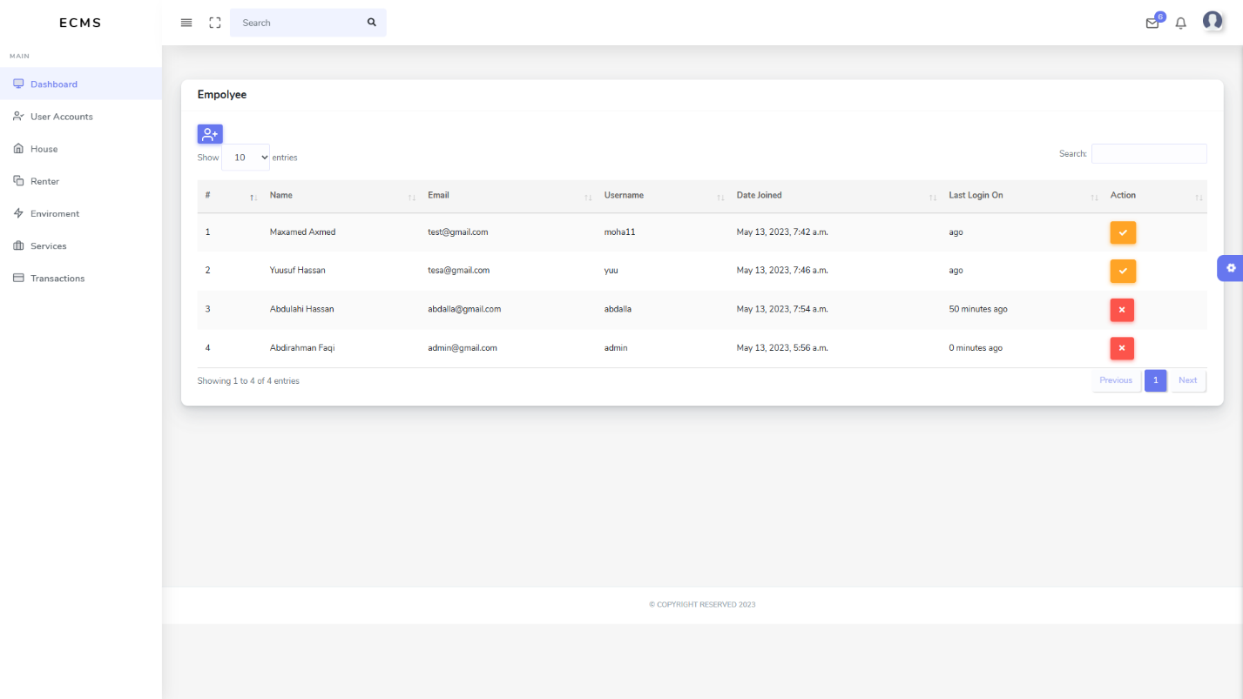

Figure 10 Users List

You can add a new account to the system by filling out the form and using the new account and you will fill all the information that appears on the form and then you will click or pressing the button that says save.

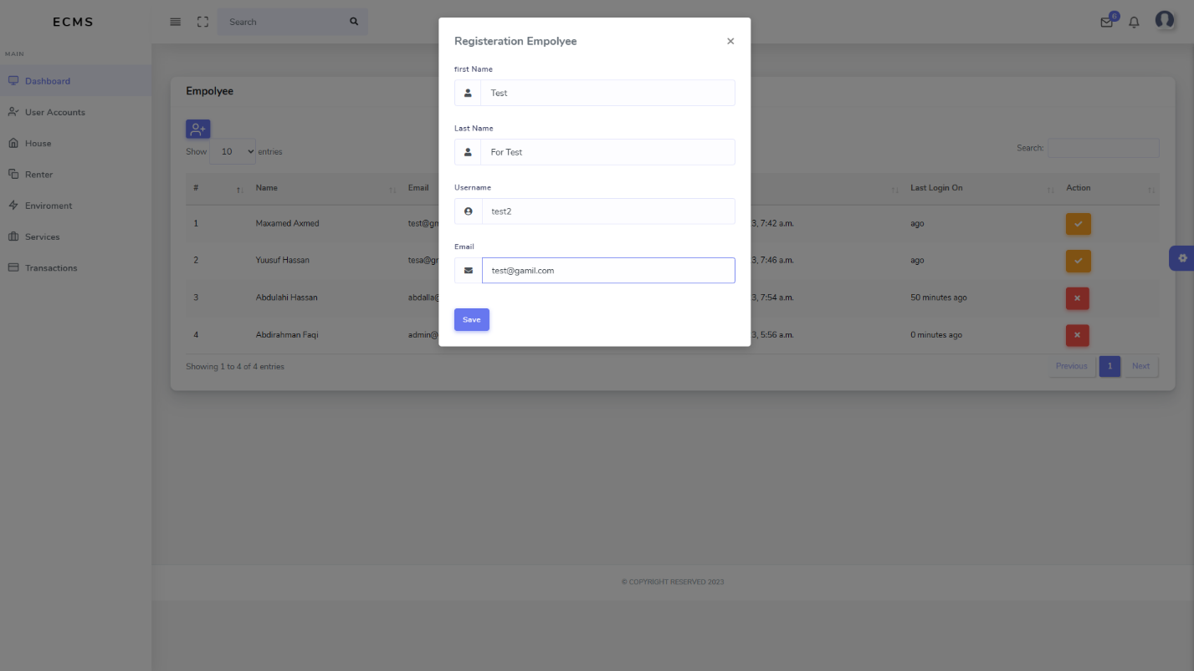as shown in the picture below.

Figure 11 Add New User Account Form

After you say save, a popup message will appear that says "You have successfully Saved this user".

Figure 12 Success Message fir User Account Saving

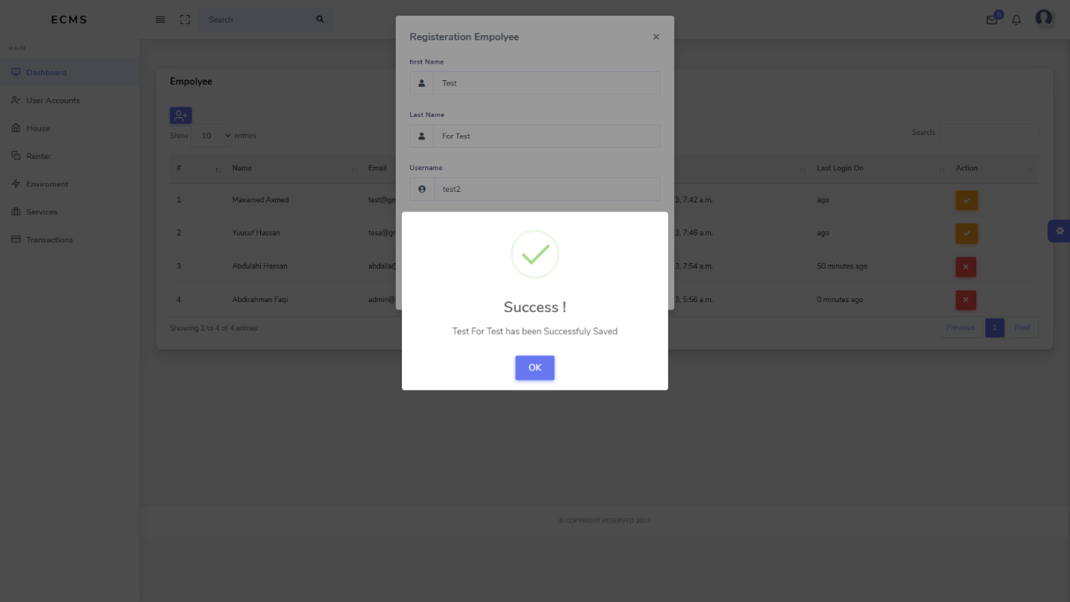

When you save a user, you will see a list of user accounts that you have saved in the entire system and you will find the list of the user you just saved.

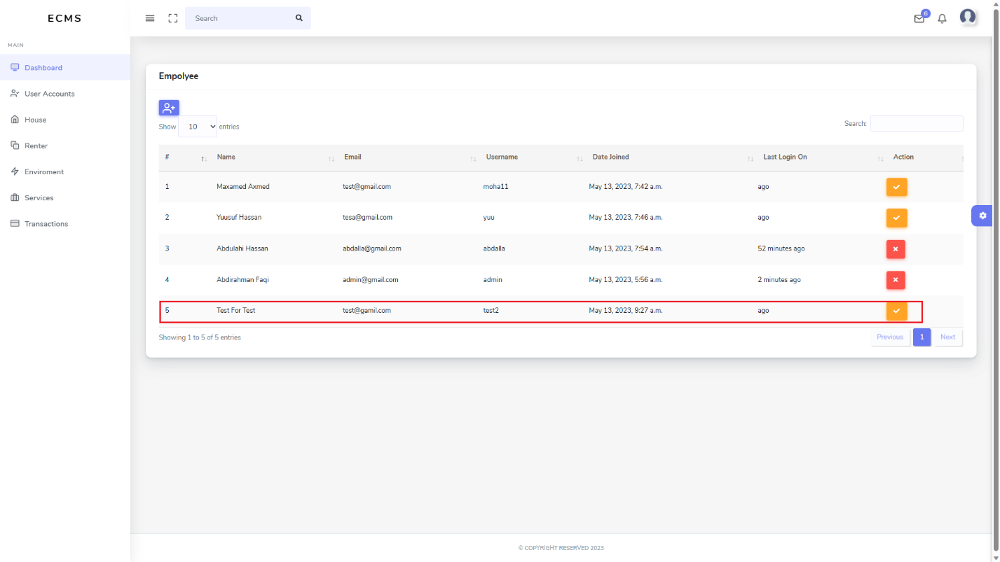If you want the user to log in to the system, you must make the user active. To make the user active, you must click on the active icon.

Figure 13 Display List in a user created

After clicking on the active icon, a modal will pop up asking you to enter a password to activate the user, after entering it, click the save button.

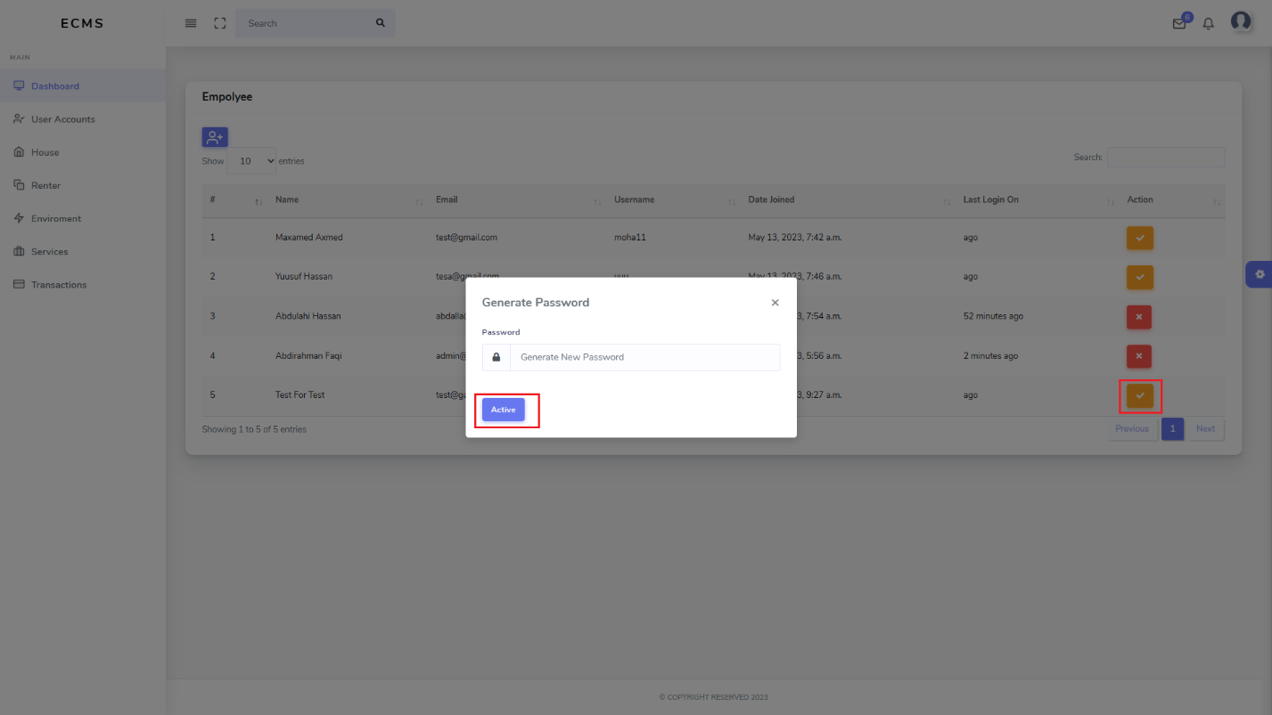

Figure 14 Making activating User by entering password

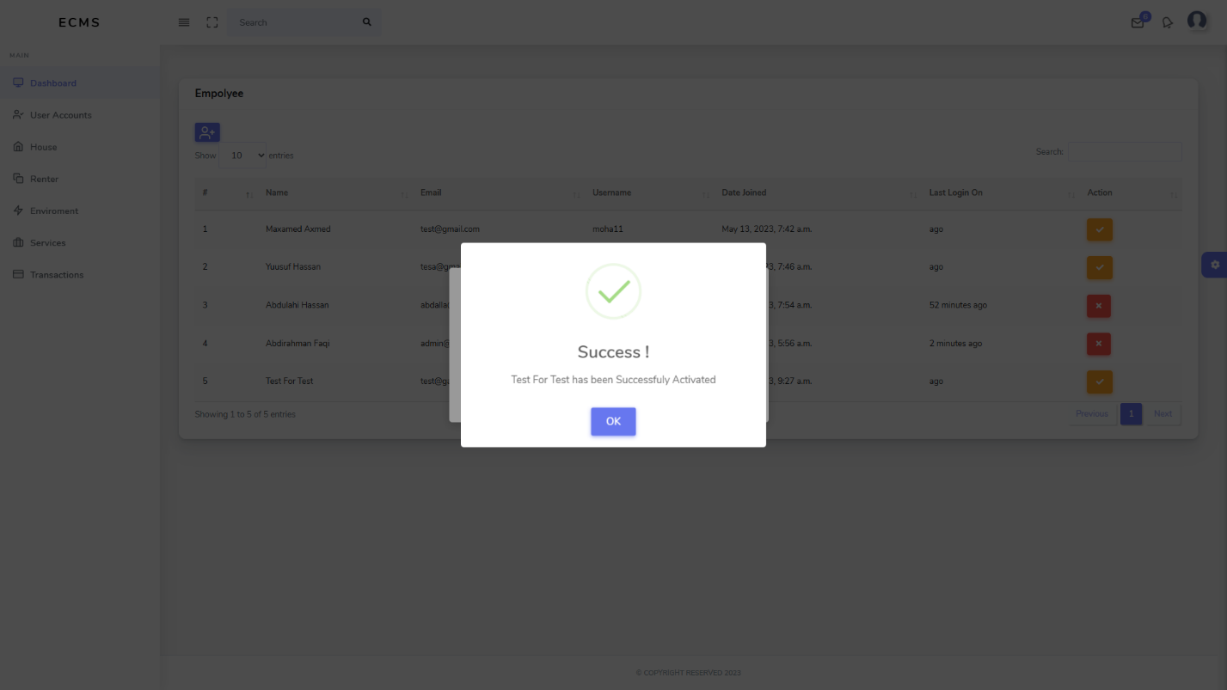After you say save, a popup message will appear that says "You have successfully Activated”.

Figure 15 Success Message for activating user

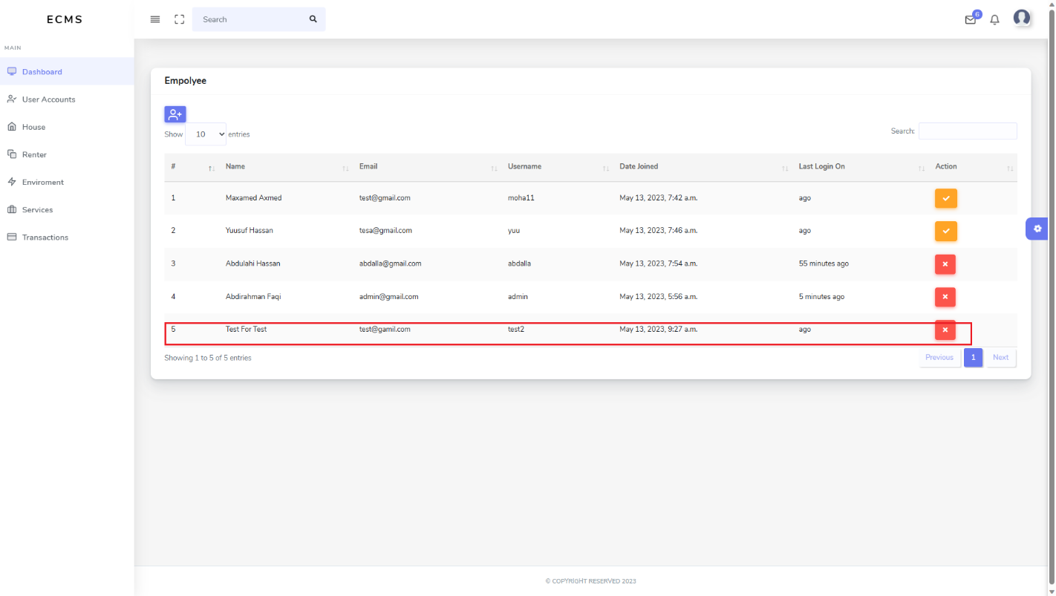When you make the user active, that user will be able to log in to the system you can also block the user and prevent him from entering the system then click on the red icon on the table to block the user.

Figure 16 Blocking User Account by Pressing Red Icon

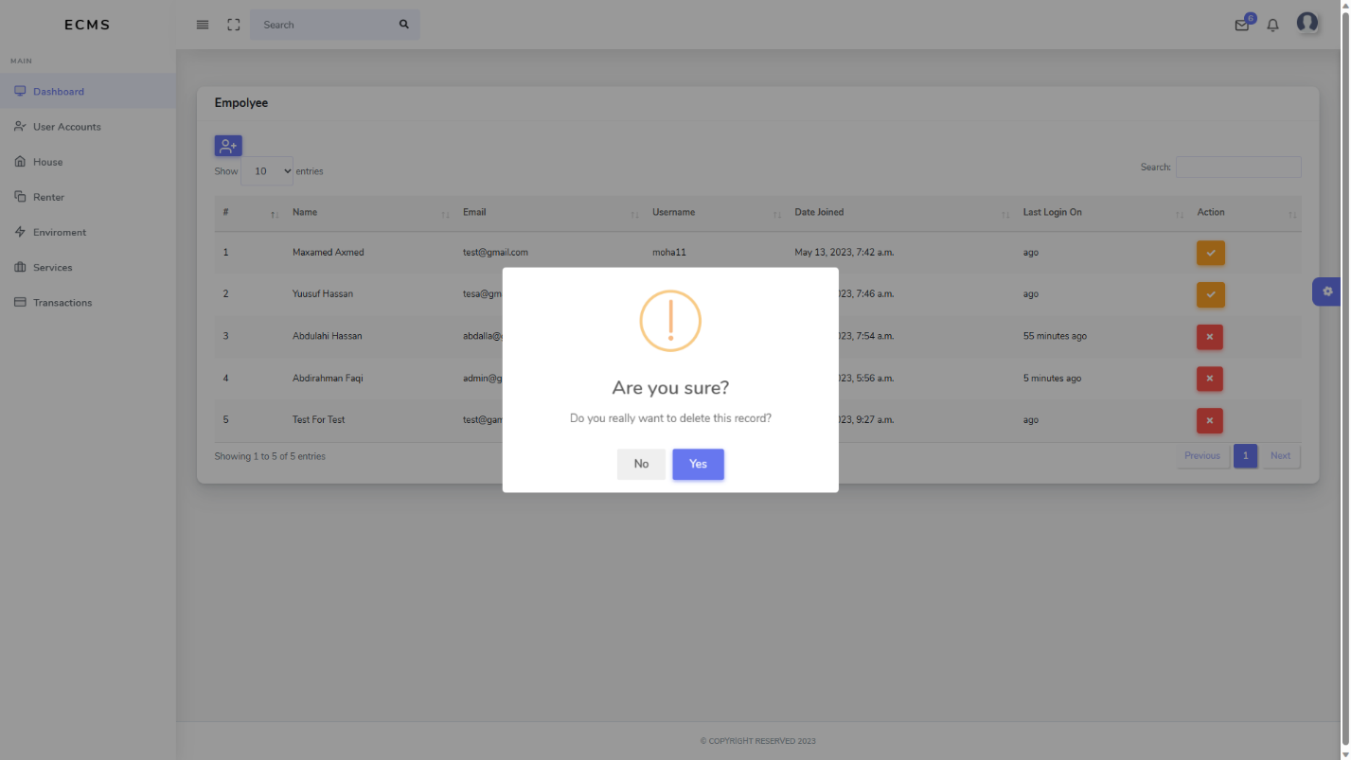After that you will click on yes to block the user

Figure 17 Confirmation Condition Press Yes

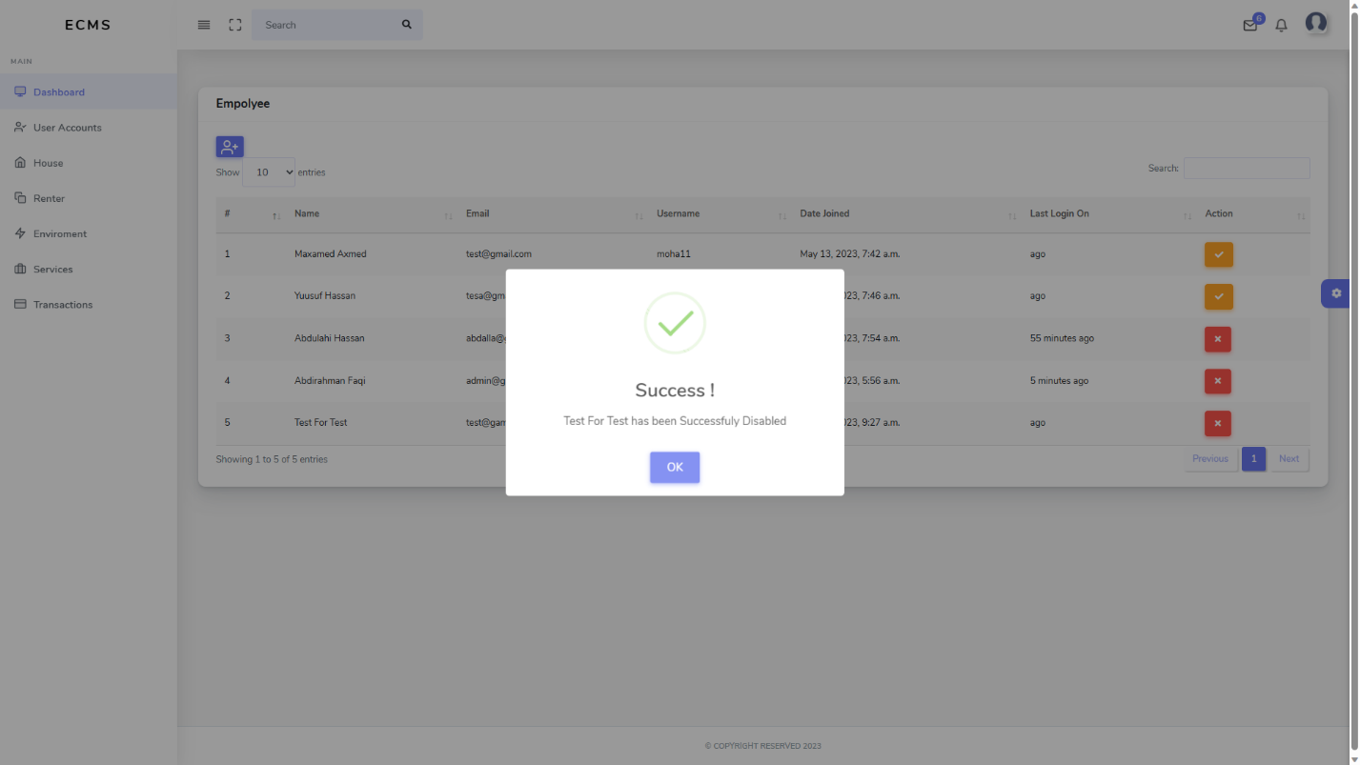After you say save, a popup message will appear that says You have successfully blocked this user.

Figure 18 Success Message for Blocking User Account

## **House Section**

When you click on House, you will first be presented with a list of all the houses in the system, and the user will be able to register a new house.

When you click on add new house, a modal form will appear. In that form, you will fill in all the requirements of the form that are mentioned on the top of the form and you will see the save icon.

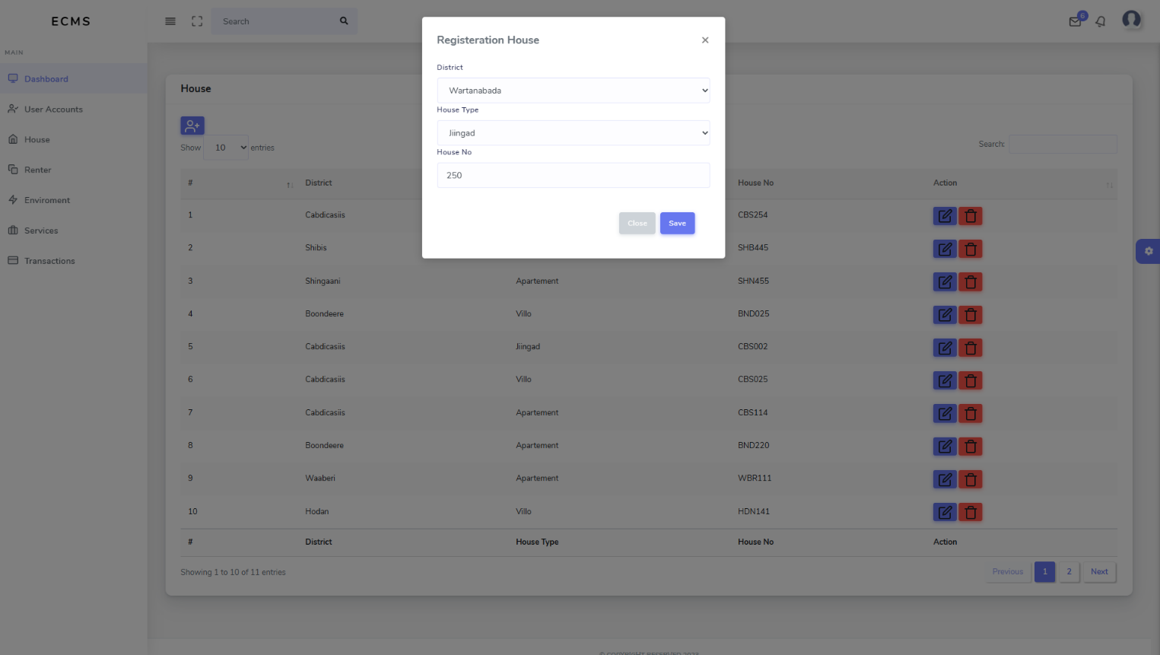

Figure 19 House Registering

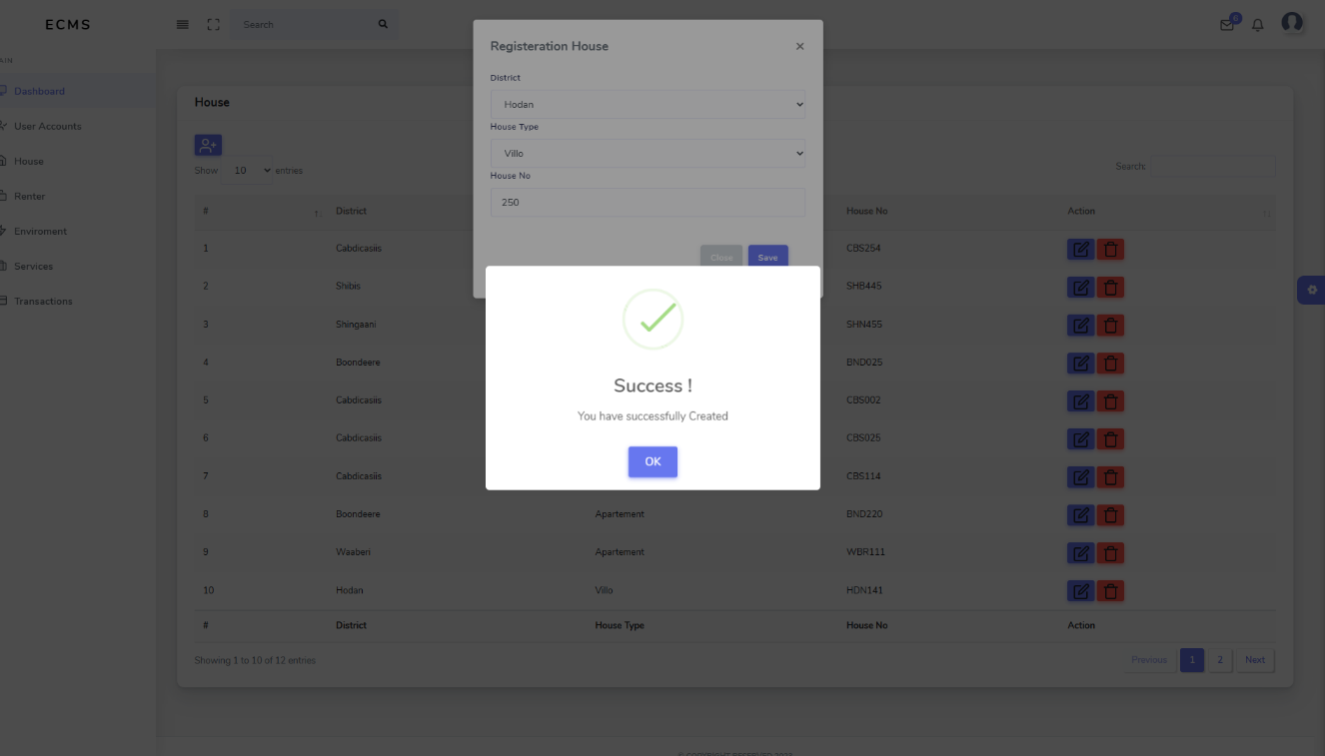After you say save, a popup message will appear saying that you have successfully saved your account.

Figure 20 Success Message for Saving House

Also, if you make a mistake in the Housing Registry, you have the ability to update it. Also, if you want, you can count it and remove it from the system.

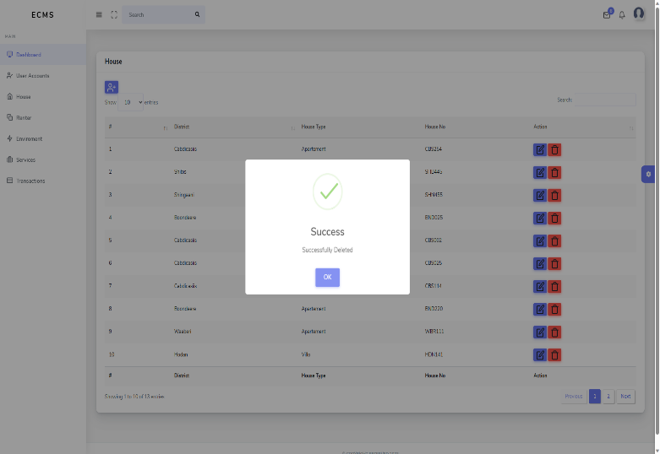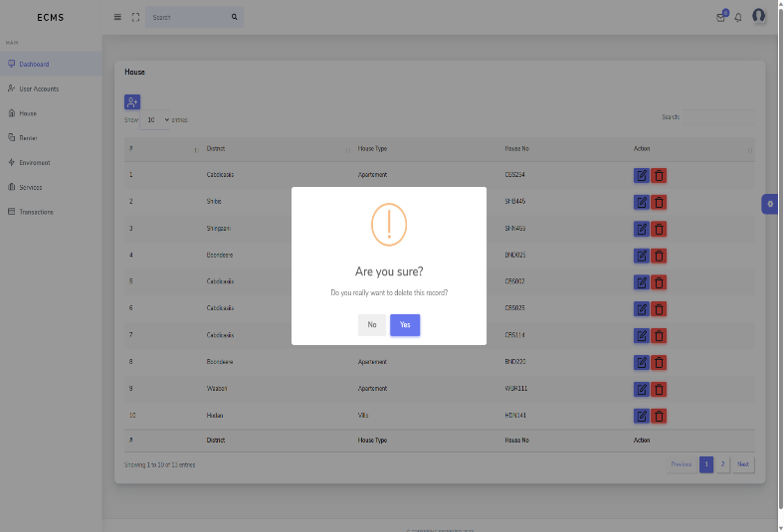

Figure 21 Confirmation of deleting Message and Success Message

## **Renter Section**

When you click on the renter section, you will first see a list of all the renters in the system. When you click on add new renter, a modal form will appear. In that form, you will fill in all the requirements of the form that are mentioned on the top of the form and you will see the save icon.

Figure 22 Adding New Renter

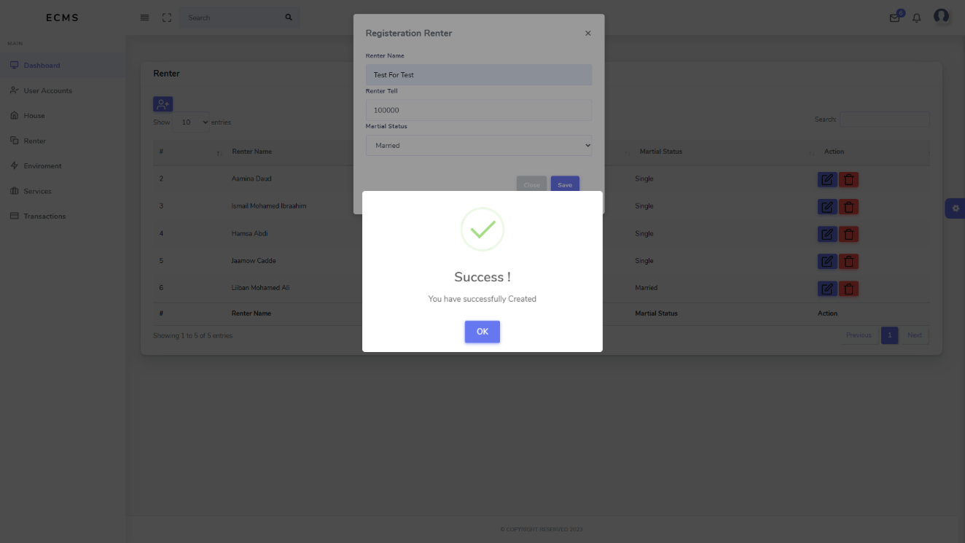After you say save, a popup message will appear saying that you have successfully saved your account.

Figure 23 Success Message For adding Renter

Also, if you make a mistake in the Renter Registry, you have the ability to update it. Also, if you want, you can count it and remove it from the system.

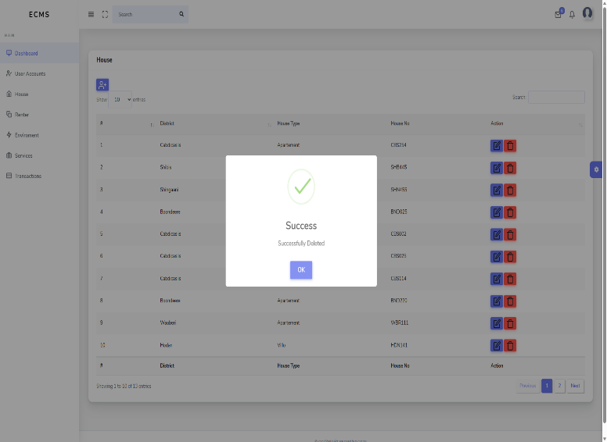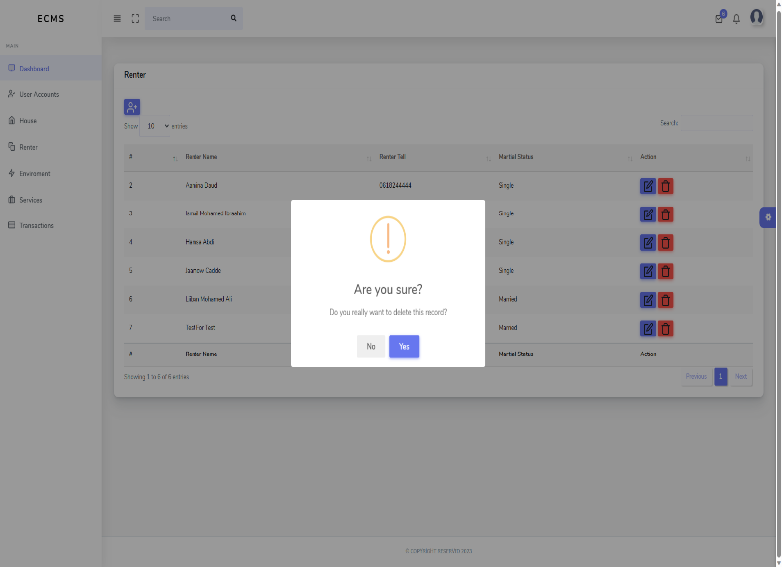

Figure 24 Conformation and Success Message for Renter

## **Environment Section**

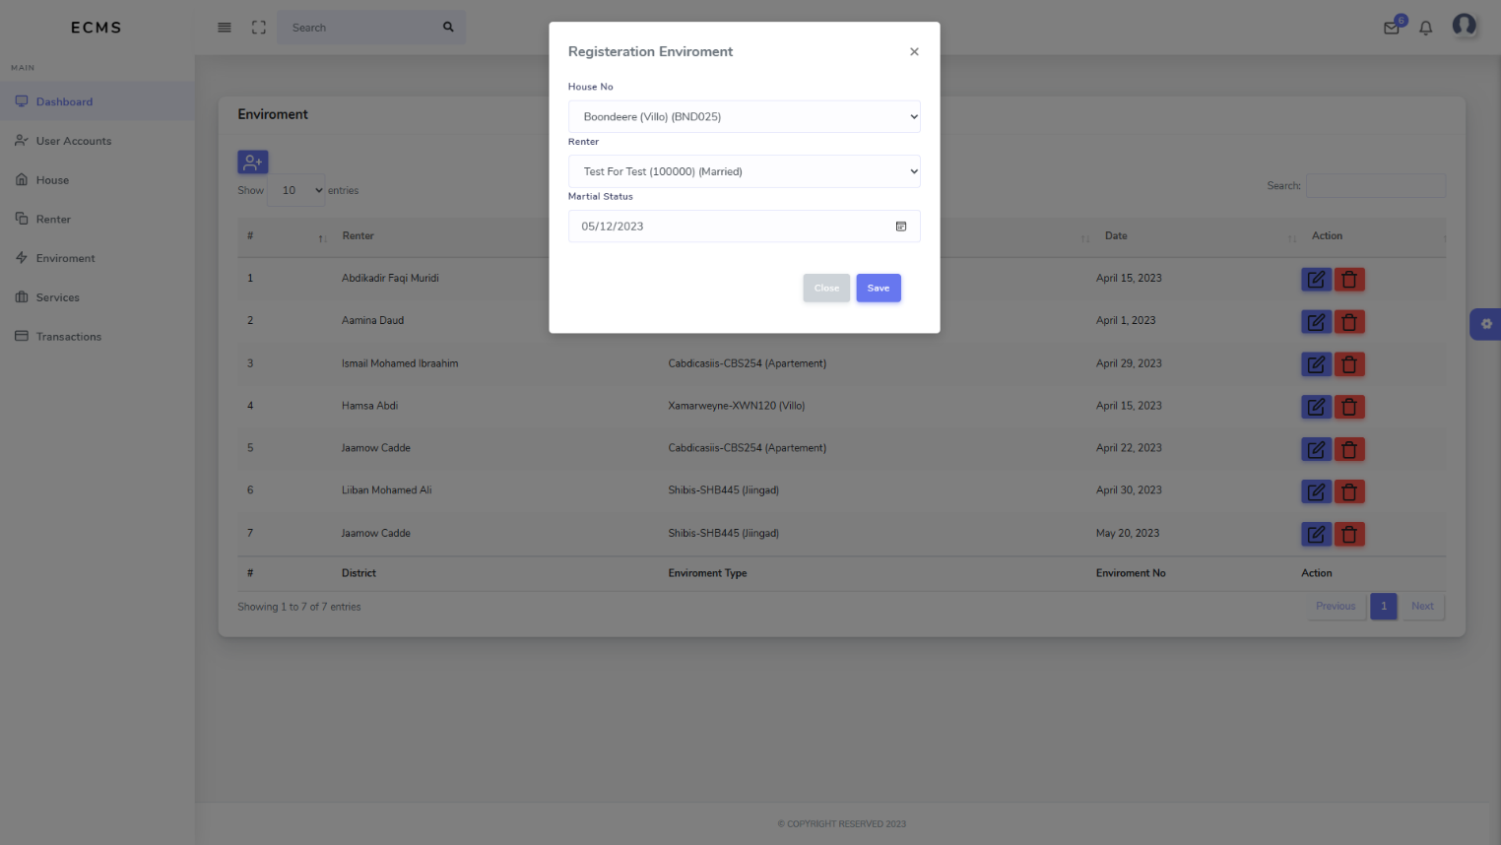When you click on the environment section, you will first see a list of all the environments in the system. When you click on add new environment, a modal form will appear. In that form, you will fill in all the requirements of the form that are mentioned on the top of the form and you will see the save icon.

Figure 25Adding Environment

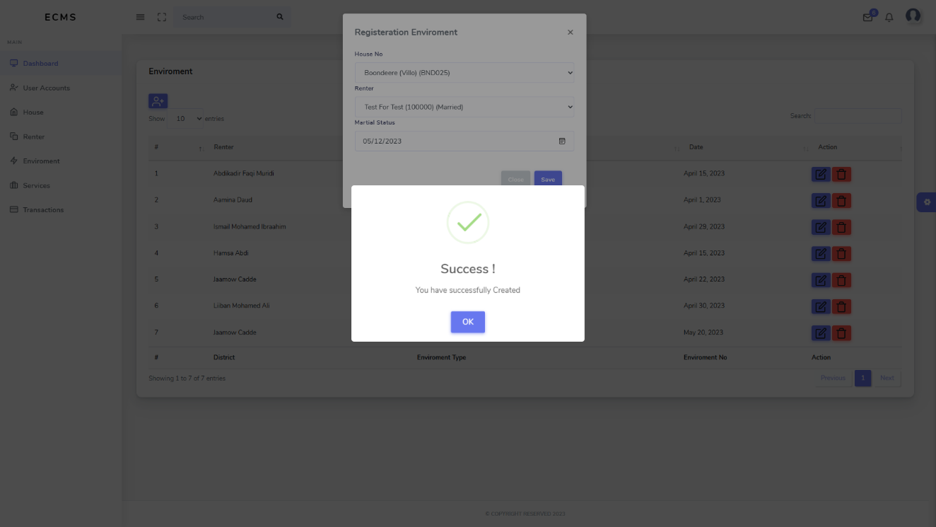After you say save, a popup message will appear saying that you have successfully saved your account.

Figure 26 Saving Environment

## **Services Section**

This section has been filed in each area for the amount of service that has been done every month, the area will be charged a fee of 5 dollars, we will file your information here.

So when the user clicks on this section, the information will be displayed for all the areas that have been serviced, and the user can also create a new service and at the same time the area will be charged the monthly fee.

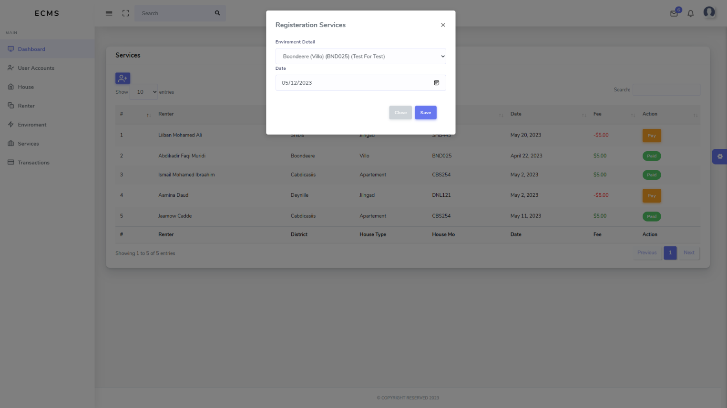So, to create a new service, it is necessary to click on the add sign, then a form will appear, try to fill in the form, and then click on Save.

Figure 27 adding new services

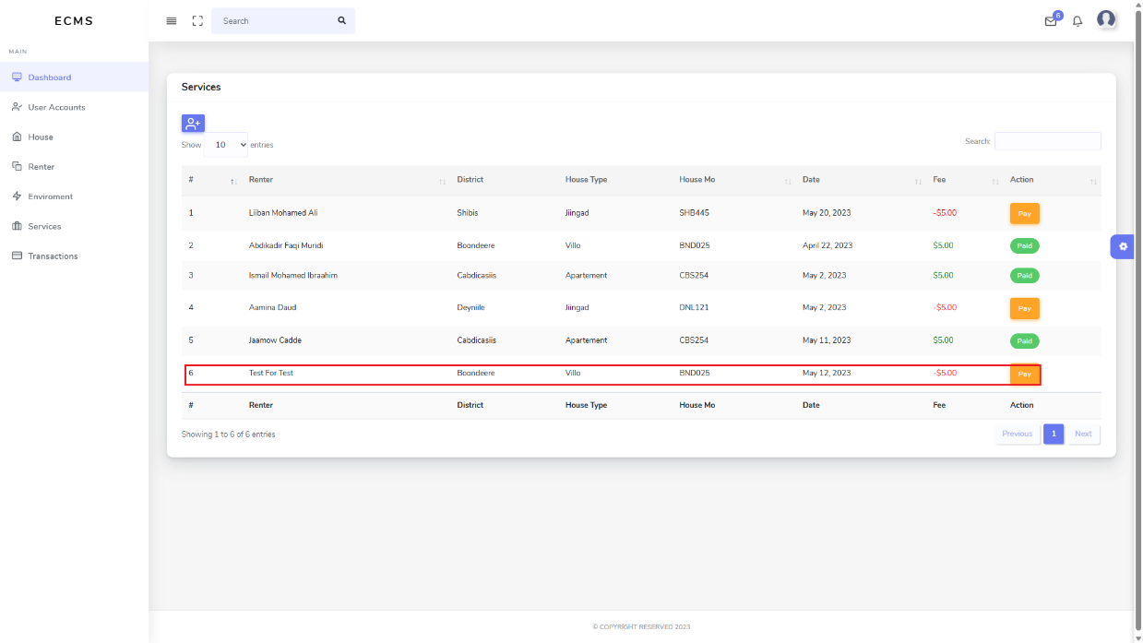After the new service is saved, it will appear in the list of our services in the areas, and you will also see the areas where the money is outstanding and others.

Figure 28 View in List with Registered Services

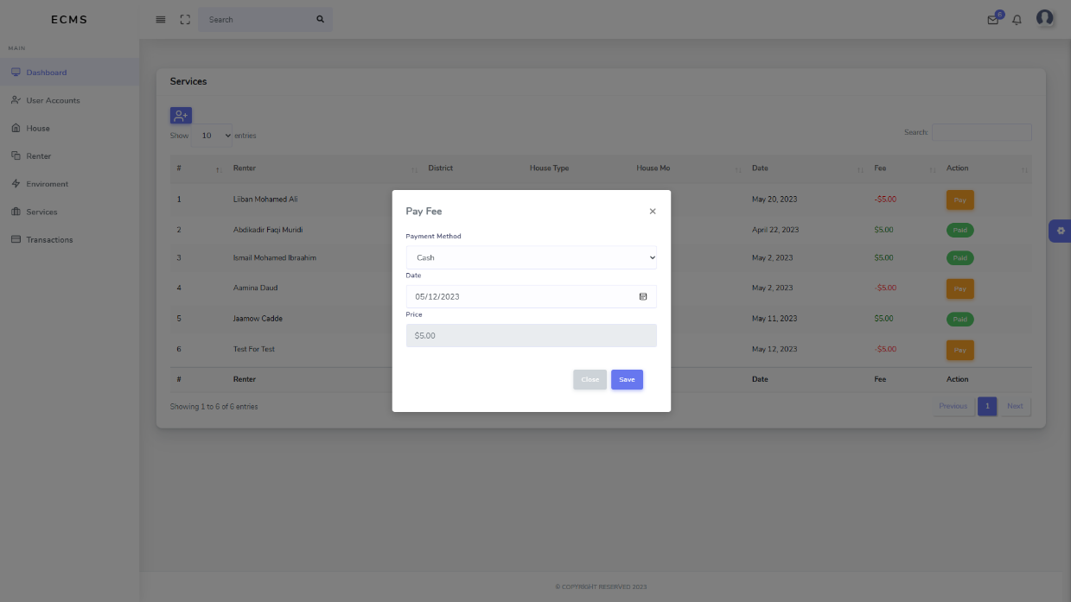To register a payment, you will click on the sign that says pay, then a form will appear with the payment information, and you will fill in the form, then you will click on the place that says save.

Figure 29 Making Payment

After you say save, a popup message will appear with an invoice saying that you have successfully paid the money.

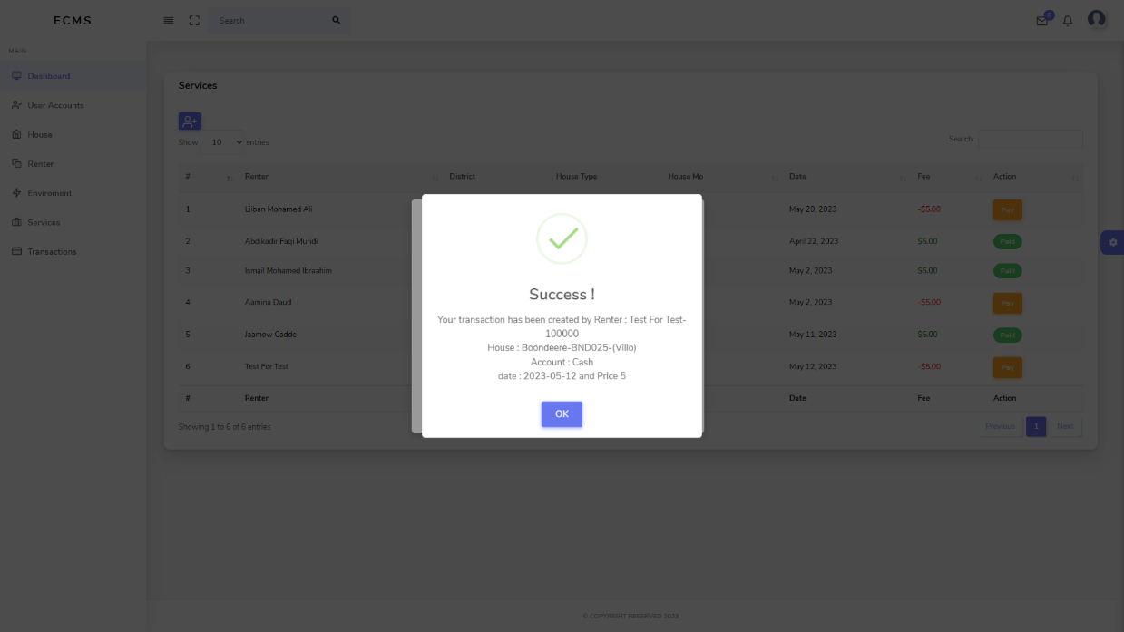

Figure 30 Success Message with Mini Invoice

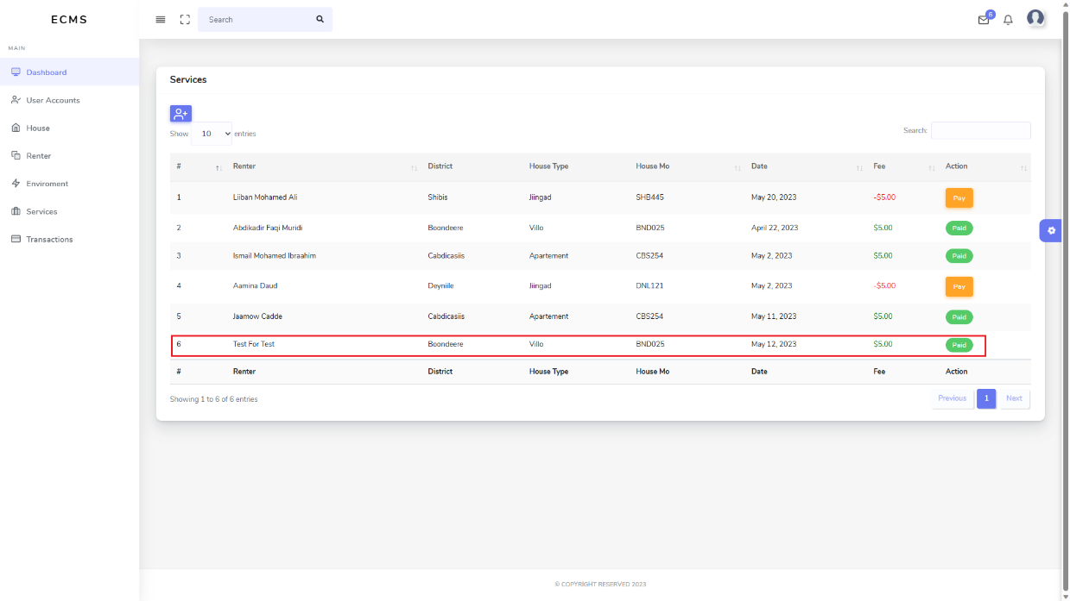after you say ok it will bring you the list of services you have done and you will see that it has changed from the service that we have registered and it has changed to a complete one and even paid for it

Figure 31 Changing the Status of Services

## **Transaction Section**

In this section, all the information about the payments will be displayed and the information will be read in the system, and the user will be able to print an invoice.

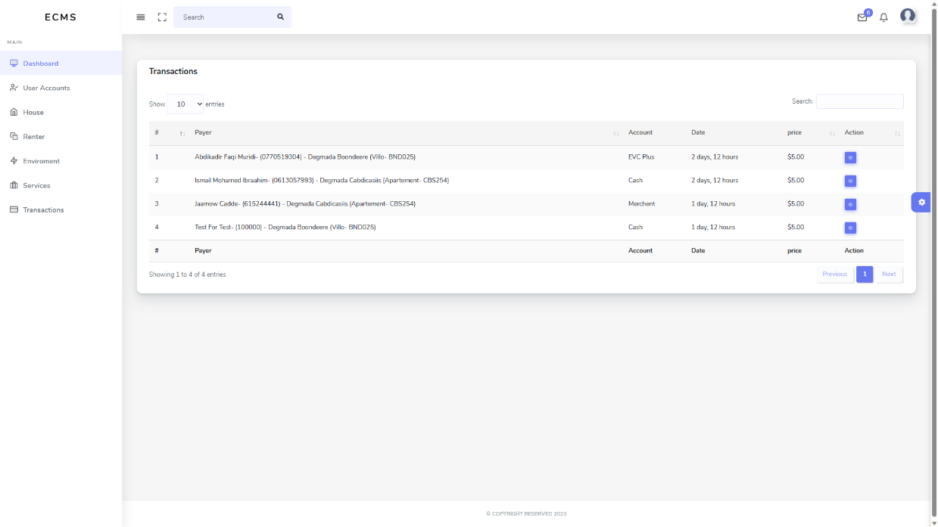

Figure 32 Transaction View List

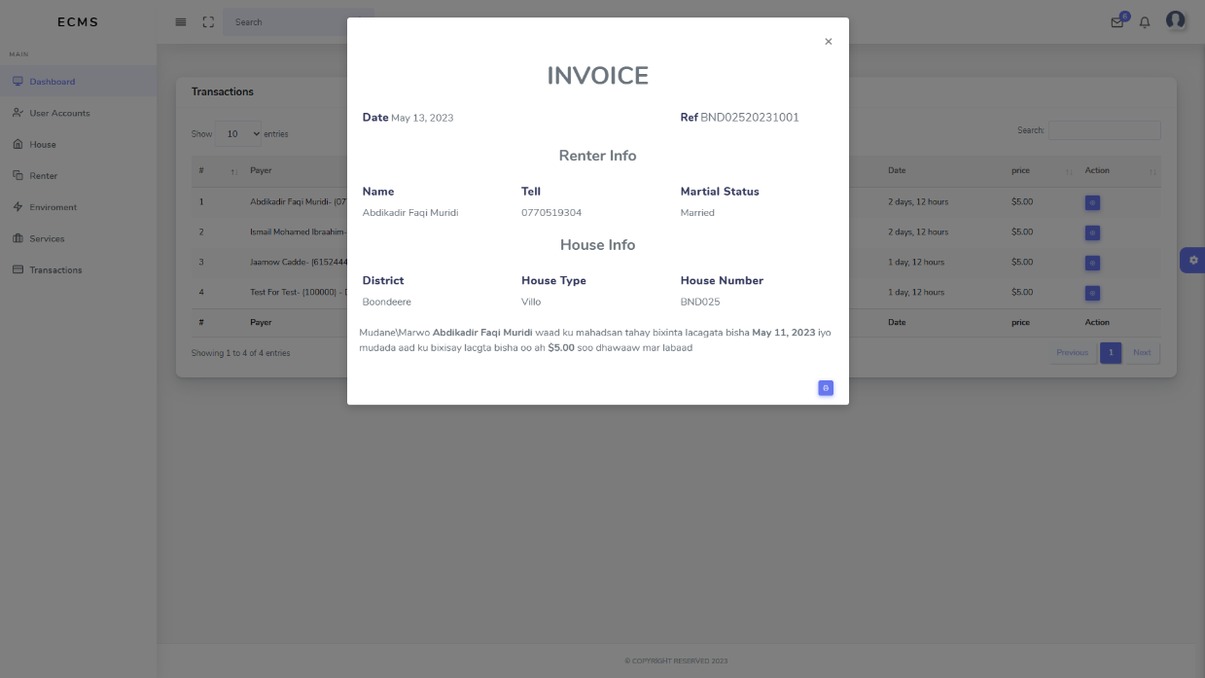To print an invoice, click on the view icon on the table, then all the information related to the transaction will appear.

Figure 33 Displaying Invoice

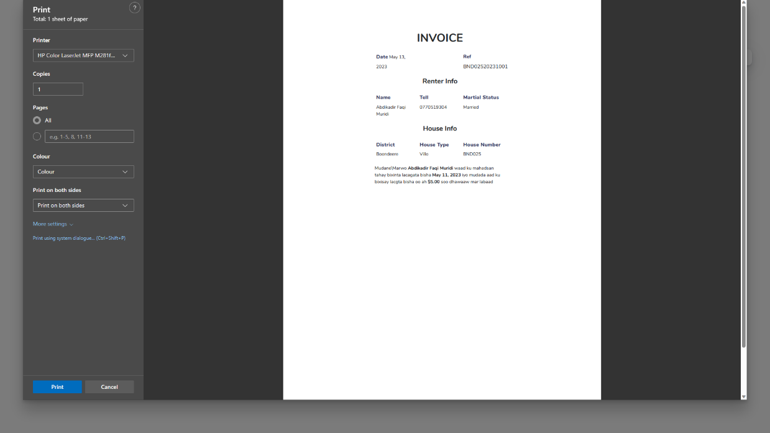then you click on the print icon and then you select your printer’s name and then you have print.

Figure 34 Printing Invoice

# **Conclusion**

the implementation of an Environmental Cleaning Management System (ECMS) is an effective approach for organizations to maintain a clean and safe environment for their employees, customers, and stakeholders. Through the development and implementation of the ECMS, organizations can actively manage their cleaning activities and ensure that they are in compliance with regulatory requirements.

The research conducted for this thesis project has demonstrated that the ECMS is a comprehensive and effective system for managing environmental cleaning activities. The ECMS provides a structured approach for planning, scheduling, executing, and monitoring cleaning tasks. The integration of advanced technologies such as data analytics, automation, and sensors can further enhance the effectiveness and efficiency of the system.

Furthermore, the research findings have confirmed that the ECMS can be customized to fit the specific needs of different organizations. The ECMS can be integrated with other systems such as inventory management and quality control to streamline operations and improve overall performance. The implementation of the ECMS has also been shown to improve cleaning efficiency, reduce the risk of contamination or infection, and meet regulatory requirements.

In the future, the ECMS is expected to become even more critical as organizations continue to face increasing pressure to maintain high standards of hygiene and cleanliness. The ongoing COVID-19 pandemic has highlighted the importance of effective cleaning and disinfection practices, and the ECMS can play a critical role in ensuring that organizations are able to maintain a safe and healthy environment for their employees and customers.

Overall, the findings of this thesis project indicate that the implementation of an ECMS is a powerful tool for organizations seeking to improve their environmental cleaning practices, reduce risk, and achieve regulatory compliance. By adopting an ECMS, organizations can ensure that they are providing a safe and healthy environment for all stakeholders, while also improving operational efficiency and reducing costs.

THANK YOU

THE END